Chapter 6. Product Limit stimator Peter smith

### Required libraries

library(survival)

## Warning: package 'survival' was built under R version 4.0.4

knitr::include_graphics("6_2.PNG")

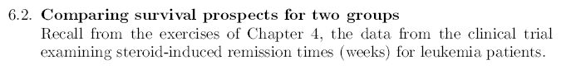

### Required data

### Patients whowere given 6-mercaptopurine  
### The time for 6-MP and the placebo time were given in weeks  
  
MP <- c(6,6,6,6,7,9,10,10,11,13,16,17,19,20,22,23,25,32,32,34,35)  
cens1 <- c(1,1,1,0,1,0,1,0,0,1,1,0,0,0,1,1,0,0,0,0,0)  
  
### Patients who were given Placebo  
  
placebo <- c(1,1,2,2,3,4,4,5,5,8,8,8,8,11,11,12,12,15,17,22,23)  
cens2 <- rep(1,21)

### Joining the Data

### Joining the MP and placebo data in the same vector   
  
Total <- c(MP,placebo)  
  
### Converting the given times to months by dividing the number of weeks/4.345  
  
Total <- Total/4.345  
  
### Joining the MP and placebo censored data in the same vector   
  
cens <- c(cens1, cens2)  
  
### Creating data groups MP = 1, Placebo = 0  
  
groups <- c(rep(1,21),rep(0,21))

### PL-Estimator

### Calculating the PL estimator using the survival library  
  
km.model <- survfit(Surv(Total,cens)~ groups)

### Comparation Chart

plot(km.model, conf.int=F,col=c("red", "blue"), xlab = "Remission time (in months)", ylab = "S(t)", main="Comparing the survival time for the 2 groups", mark.time = TRUE, lwd = 2, las=1)  
legend("topright", legend=c("6-MP","Placebo"), lty = 1, lwd = 2, col=c("blue", "red"), bty="n")

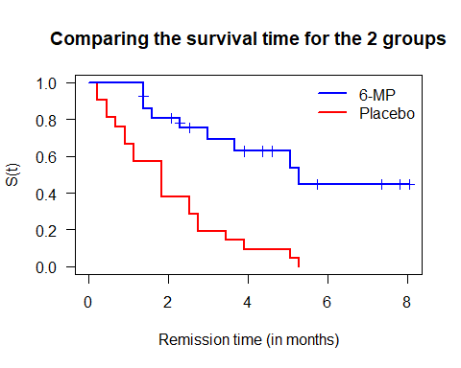

knitr::include_graphics("6_2_a.PNG")



From the analysis of the graphs, it can be seen that the time for the treatment group administered the 6-MP steroid to enter remission is longer than that of the patients administered the placebo. We can also see that the survival function for the treatment group is above that of the placebo group, clearly indicating that the efficacy of the 6-MP steroid, of course this is not the case at all times and the survival function for both groups is maintained at 100%, until the first week where both graphs are far apart, corroborating the effectiveness of the treatment because the risk of entering remission is lower.

knitr::include_graphics("6_2_b.PNG")

 Using the graphs for both groups we can estimate that the probability of survival, i.e. not entering remission after 3 months, for the treatment group is about 70%, while for the placebo group it is about 20%.

knitr::include_graphics("6_2_c.PNG")



### summary function on the KM model  
  
summary(km.model)

## Call: survfit(formula = Surv(Total, cens) ~ groups)  
##   
## groups=0   
## time n.risk n.event survival std.err lower 95% CI upper 95% CI  
## 0.230 21 2 0.9048 0.0641 0.78754 1.000  
## 0.460 19 2 0.8095 0.0857 0.65785 0.996  
## 0.690 17 1 0.7619 0.0929 0.59988 0.968  
## 0.921 16 2 0.6667 0.1029 0.49268 0.902  
## 1.151 14 2 0.5714 0.1080 0.39455 0.828  
## 1.841 12 4 0.3810 0.1060 0.22085 0.657  
## 2.532 8 2 0.2857 0.0986 0.14529 0.562  
## 2.762 6 2 0.1905 0.0857 0.07887 0.460  
## 3.452 4 1 0.1429 0.0764 0.05011 0.407  
## 3.913 3 1 0.0952 0.0641 0.02549 0.356  
## 5.063 2 1 0.0476 0.0465 0.00703 0.322  
## 5.293 1 1 0.0000 NaN NA NA  
##   
## groups=1   
## time n.risk n.event survival std.err lower 95% CI upper 95% CI  
## 1.38 21 3 0.857 0.0764 0.720 1.000  
## 1.61 17 1 0.807 0.0869 0.653 0.996  
## 2.30 15 1 0.753 0.0963 0.586 0.968  
## 2.99 12 1 0.690 0.1068 0.510 0.935  
## 3.68 11 1 0.627 0.1141 0.439 0.896  
## 5.06 7 1 0.538 0.1282 0.337 0.858  
## 5.29 6 1 0.448 0.1346 0.249 0.807

Using the summary function on the kaplan-maier model, to calculate the estimated value of the survival function beyond 3 months, we have that for the group to which the treatment was administered it was 69%, while for the placebo group it was 19.05%.

knitr::include_graphics("6_3.PNG")

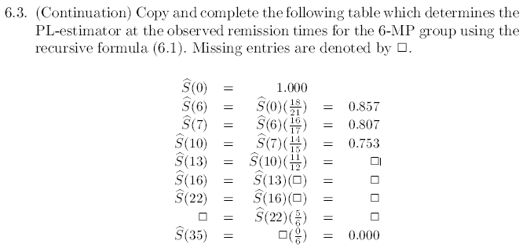

To fill in the values of the PL- estimator for 6-MP group, we will use definition 6.3 to manually calculate the values as shown below.

### Turning data into a DF  
  
mpData <- as.data.frame(cbind(MP, cens1))

Manual calculation

knitr::include_graphics("6_3R.png")

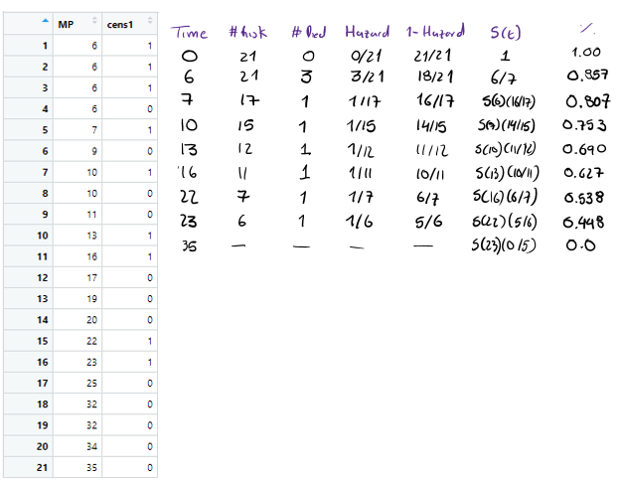

To verify the calculations performed we will calculate the KM estimator on the training group data only.

km.modelMP <- survfit(Surv(MP,cens1)~ 1)  
summary(km.modelMP)

## Call: survfit(formula = Surv(MP, cens1) ~ 1)  
##   
## time n.risk n.event survival std.err lower 95% CI upper 95% CI  
## 6 21 3 0.857 0.0764 0.720 1.000  
## 7 17 1 0.807 0.0869 0.653 0.996  
## 10 15 1 0.753 0.0963 0.586 0.968  
## 13 12 1 0.690 0.1068 0.510 0.935  
## 16 11 1 0.627 0.1141 0.439 0.896  
## 22 7 1 0.538 0.1282 0.337 0.858  
## 23 6 1 0.448 0.1346 0.249 0.807

As we can see the summary function shows that the manually calculated data match the data generated by the software.

knitr::include_graphics("6_6.PNG")



### Required data

## Stanford Heart Transplat Data  
  
## Reading data  
  
heart <- read.csv("heart_data.csv", header=T,sep=";")  
### Shows the first 5 rows  
head(heart)

## Days Cens Age T5  
## 1 15 1 54.3 1.11  
## 2 3 1 40.4 1.66  
## 3 624 1 51.0 1.32  
## 4 46 1 42.5 0.61  
## 5 127 1 48.0 0.36  
## 6 64 1 54.6 1.89

### Data sorting based on the amount of days  
  
i <- order(heart$Days)  
heart <- heart[i,]  
  
### Shows the first 5 rows from the sorted data  
  
head(heart)

## Days Cens Age T5  
## 16 1 1 54.2 0.47  
## 68 1 0 35.2 0.67  
## 69 1 1 41.5 0.87  
## 2 3 1 40.4 1.66  
## 10 10 1 55.3 2.76  
## 48 12 1 29.2 0.61

### PL- Estimator

km.modelH <- survfit(Surv(heart$Days,heart$Cens)~1)  
  
st <-km.modelH$surv  
tekm <- km.modelH$time  
inv_Phi <- qnorm(st)

### Graficando probabilidad

plot(km.modelH, conf.int=T, xlab = "Time (Days)", ylab="% Alive = S(t)", main="KM-Model for Heart Transplat Patients")

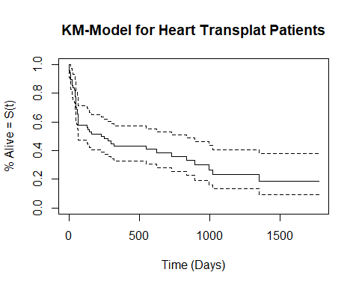

summary(km.modelH)

## Call: survfit(formula = Surv(heart$Days, heart$Cens) ~ 1)  
##   
## time n.risk n.event survival std.err lower 95% CI upper 95% CI  
## 1 69 2 0.971 0.0202 0.9322 1.000  
## 3 66 1 0.956 0.0247 0.9091 1.000  
## 10 65 1 0.942 0.0283 0.8876 0.999  
## 12 64 1 0.927 0.0315 0.8672 0.991  
## 14 62 1 0.912 0.0343 0.8470 0.982  
## 15 61 1 0.897 0.0369 0.8275 0.972  
## 23 60 1 0.882 0.0392 0.8085 0.962  
## 25 59 1 0.867 0.0413 0.7898 0.952  
## 26 58 1 0.852 0.0432 0.7715 0.941  
## 29 57 1 0.837 0.0449 0.7536 0.930  
## 39 55 1 0.822 0.0466 0.7355 0.919  
## 44 54 1 0.807 0.0482 0.7176 0.907  
## 46 53 1 0.792 0.0496 0.7000 0.895  
## 47 52 1 0.776 0.0510 0.6826 0.883  
## 48 51 1 0.761 0.0522 0.6654 0.871  
## 50 50 1 0.746 0.0533 0.6484 0.858  
## 51 49 3 0.700 0.0562 0.5983 0.819  
## 54 46 1 0.685 0.0570 0.5819 0.806  
## 60 45 1 0.670 0.0577 0.5657 0.793  
## 63 44 1 0.655 0.0584 0.5495 0.780  
## 64 43 1 0.639 0.0590 0.5336 0.766  
## 65 42 2 0.609 0.0600 0.5020 0.739  
## 66 40 1 0.594 0.0604 0.4864 0.725  
## 68 39 1 0.578 0.0607 0.4709 0.711  
## 127 37 1 0.563 0.0610 0.4550 0.696  
## 136 36 1 0.547 0.0613 0.4392 0.682  
## 147 35 1 0.532 0.0615 0.4236 0.667  
## 161 34 1 0.516 0.0617 0.4081 0.652  
## 228 32 1 0.500 0.0618 0.3922 0.637  
## 253 30 1 0.483 0.0620 0.3757 0.621  
## 280 29 1 0.466 0.0620 0.3594 0.605  
## 297 28 1 0.450 0.0620 0.3433 0.589  
## 322 26 1 0.432 0.0620 0.3266 0.573  
## 551 20 1 0.411 0.0625 0.3049 0.554  
## 624 17 1 0.387 0.0634 0.2805 0.533  
## 730 15 1 0.361 0.0642 0.2547 0.511  
## 836 13 1 0.333 0.0650 0.2273 0.488  
## 897 10 1 0.300 0.0665 0.1942 0.463  
## 994 9 1 0.267 0.0669 0.1629 0.436  
## 1024 8 1 0.233 0.0663 0.1336 0.407  
## 1350 5 1 0.187 0.0675 0.0918 0.379

knitr::include_graphics("6_6_1.PNG")

 Using the summary function, it is estimated that the probability that the patient will live for more than one year after transplantation is approximately 43%, with a estimate standar error of 0.0620

knitr::include_graphics("6_6_2.PNG")



The probability of survival after 6 to the next 6 months after heart transplantation decreases based on the model calculated in this way and the probability of survival between months 7 to 12 is given respectively by the following:

### Calculating the survival probability between the months 7 to 12  
  
result.summ <- summary(km.modelH, time=c(seq(7,12)*30.417))  
month <- (result.summ$time)/30.417  
St <- result.summ$surv  
data.frame(month, St)

## month St  
## 1 7 0.5158837  
## 2 8 0.4997623  
## 3 9 0.4831036  
## 4 10 0.4497861  
## 5 11 0.4324866  
## 6 12 0.4324866